**TEST EVIDENCE**

**TC_Password Field_11** = To verify that without enter Username enter password and click on Create

Account Button.

**Expected Result =** Validation Message Should be Display and user is not able to create Account.

**Actual Result =** Account is Created without Username.

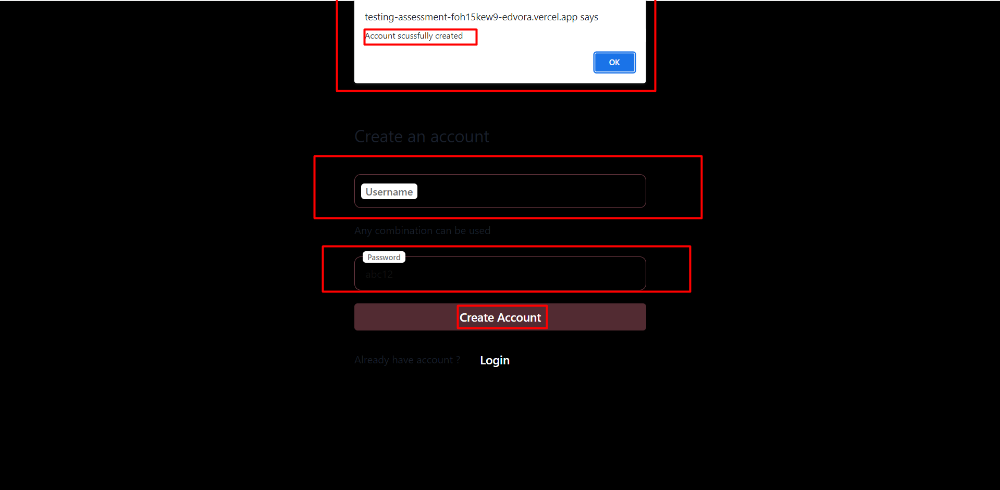

**TC_Password Field_14** = To verify that without enter password enter Username and click on Create

Account Button.

**Expected Result =** Validation Message Should be Display and user is not able to create Account.

**Actual Result =** Account is Created without Password

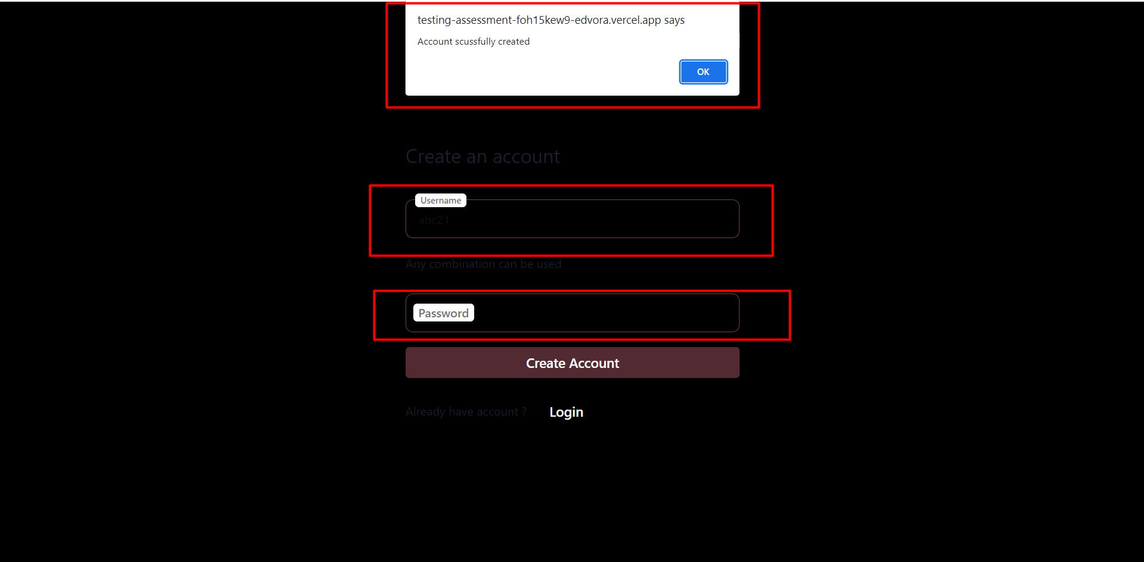

**TC_Create Account Button_17** = To verify that without enter Username and password click on Create

Account Button.

**Expected Result =** Validation Message should be display and user should not be able to create Account.

**Actual Result =** Account Created Successfully without enter Username and Password.

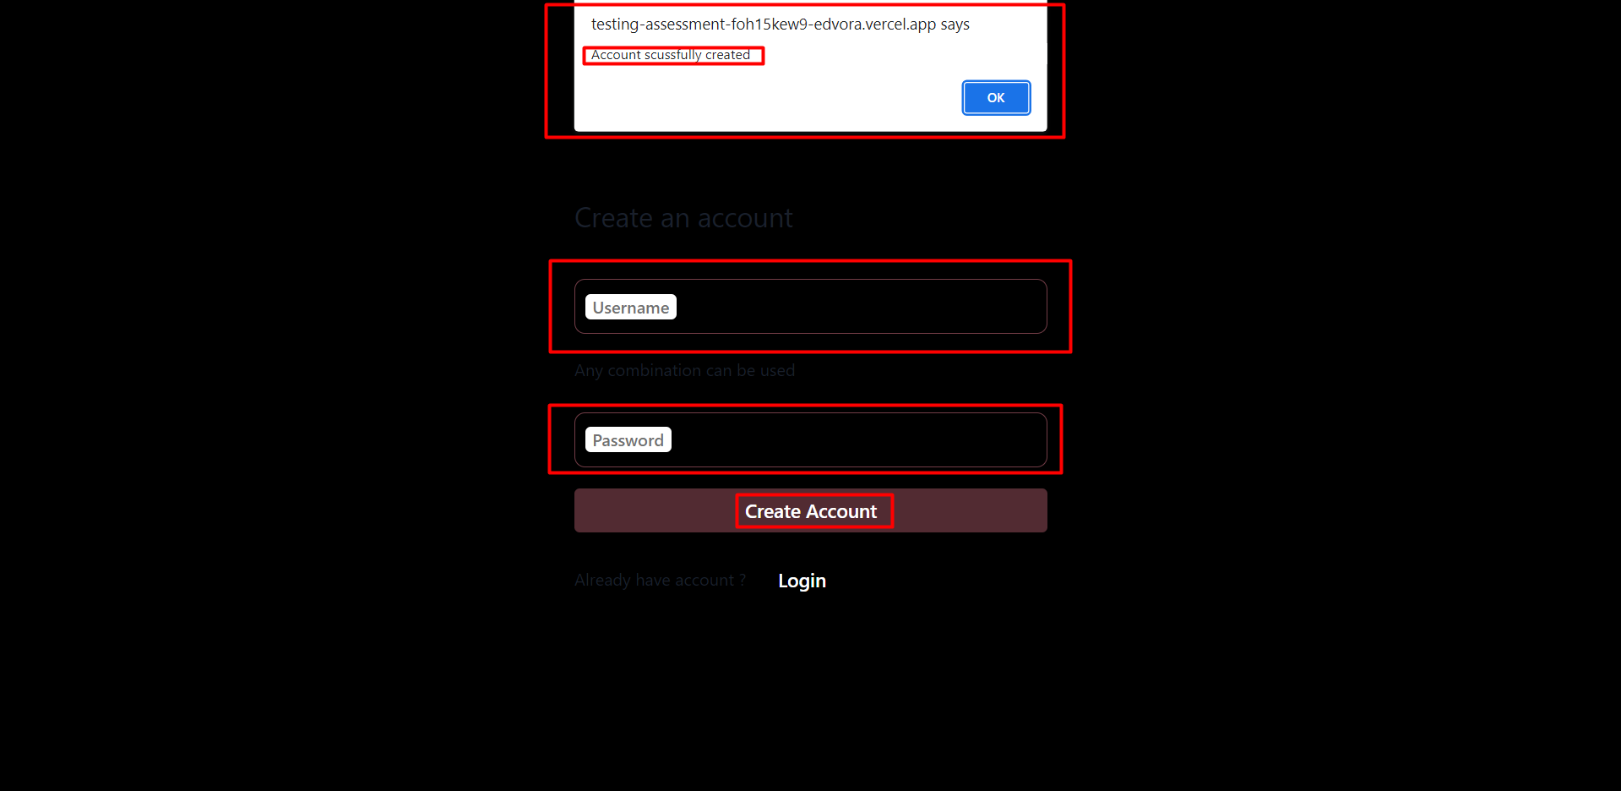

**TC_Profile Creation_22** = To verify that usre should not be able to enter Invalid Full name in full

name text Field.

**Expected Result =** Validation Message should be Display.

**Actual Result =** Invalid Full name is accepted.

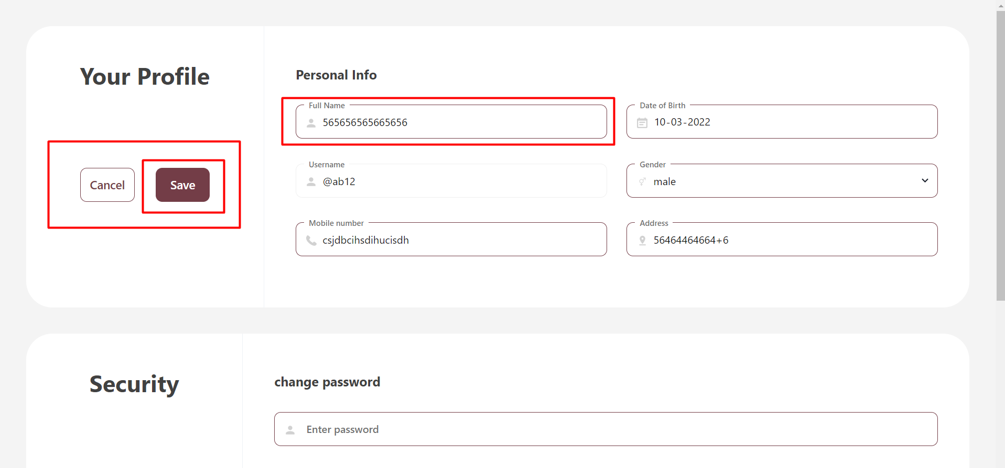

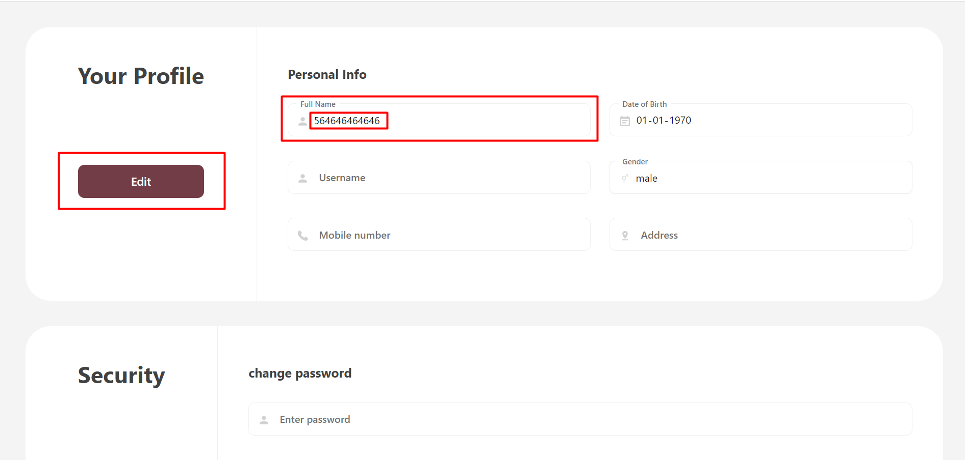

**TC_Profile Creation_26** = To verify that user Should be able to enter valid input in Date of Birth Field.

**Expected Result =** Valid Date of Birth Should be Accepted.

**Actual Result =** While enter month Date should get Change.

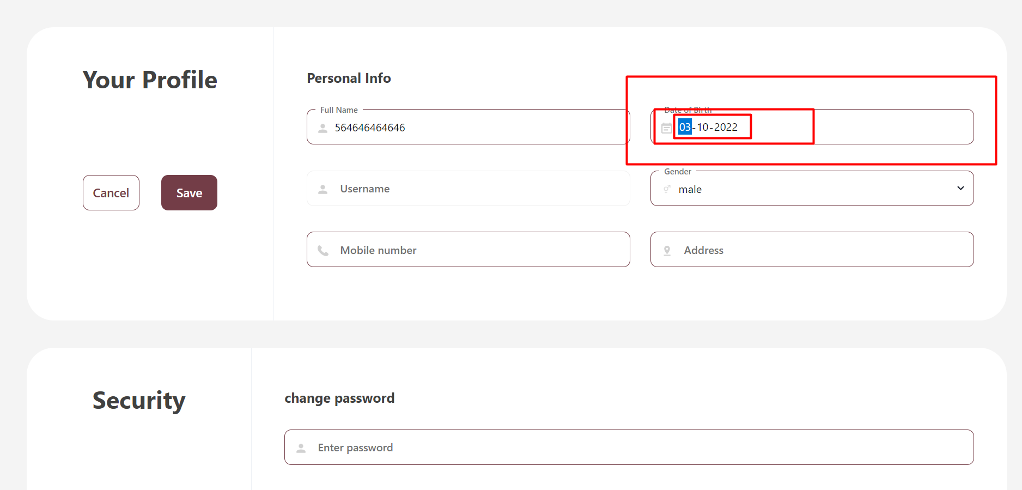

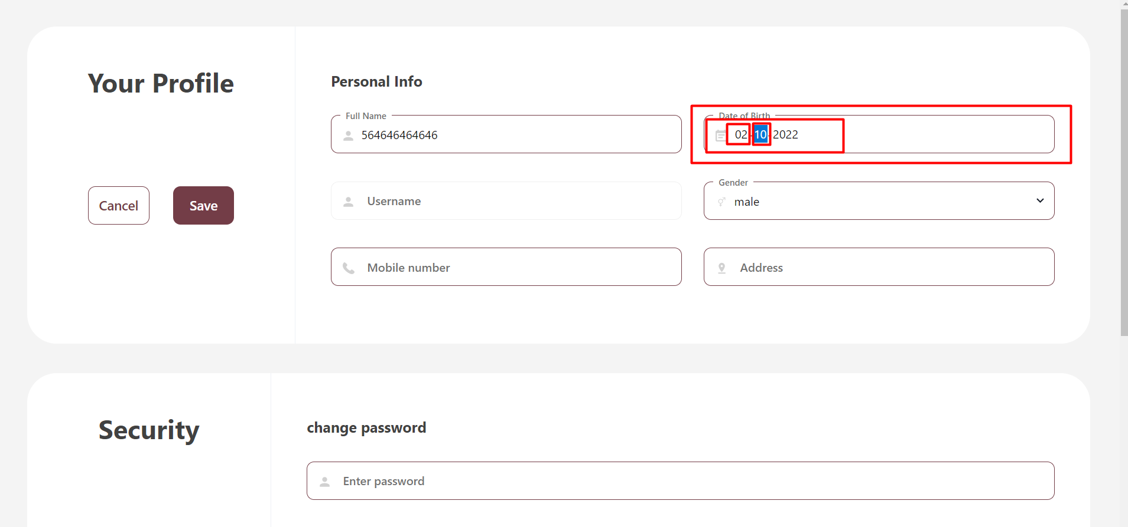

**TC_Profile Creation_33** = To verify that user should enter Invalid Mobile Number in Mobile Number

Field.

**Expected Result =** Validation message should be Display.

**Actual Result =** Invalid input is Accepted.

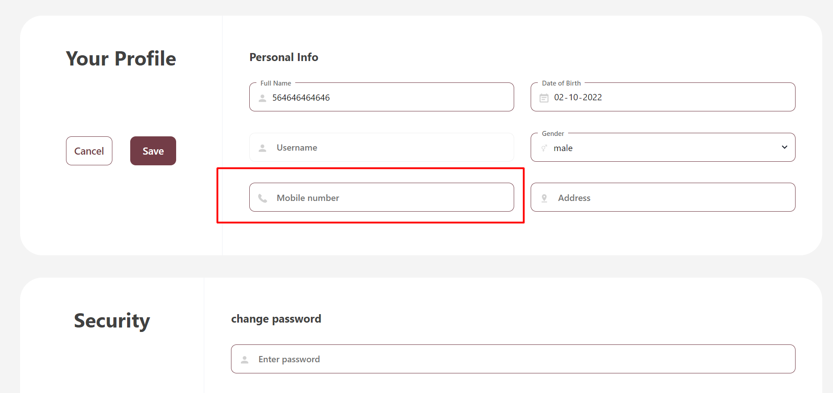

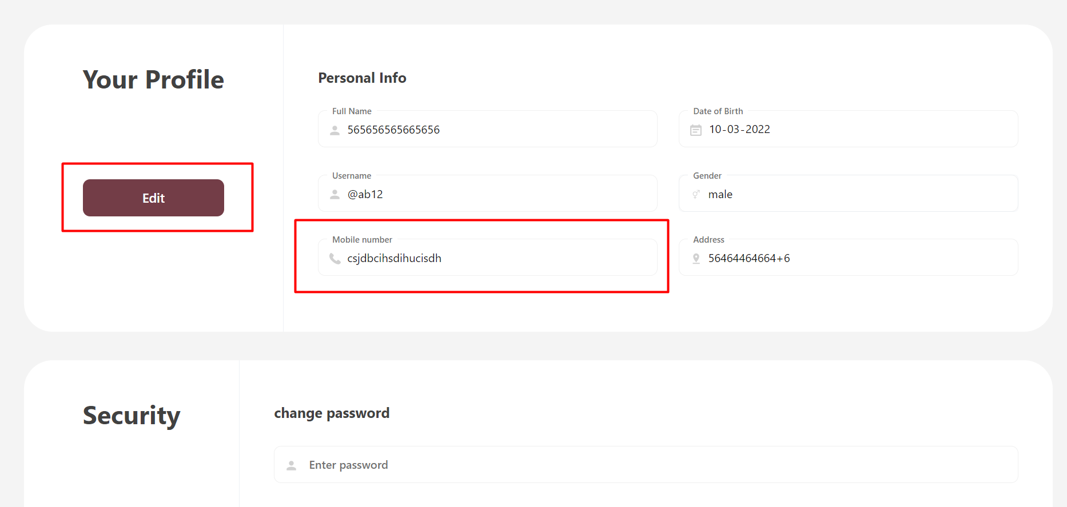

**TC_Profile Creation_36** = To verify that user should enter Invalid Input in Address field.

**Expected Result =** Validation message should be Display.

**Actual Result =** Invalid input is Accepted.

